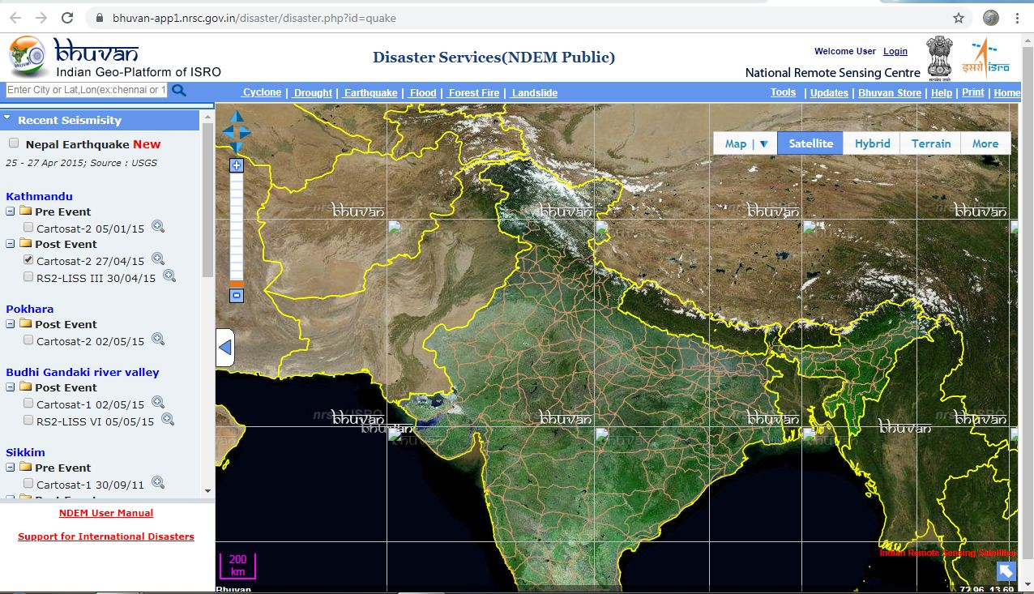

(source:bhuwan.nrsc.gov.in)

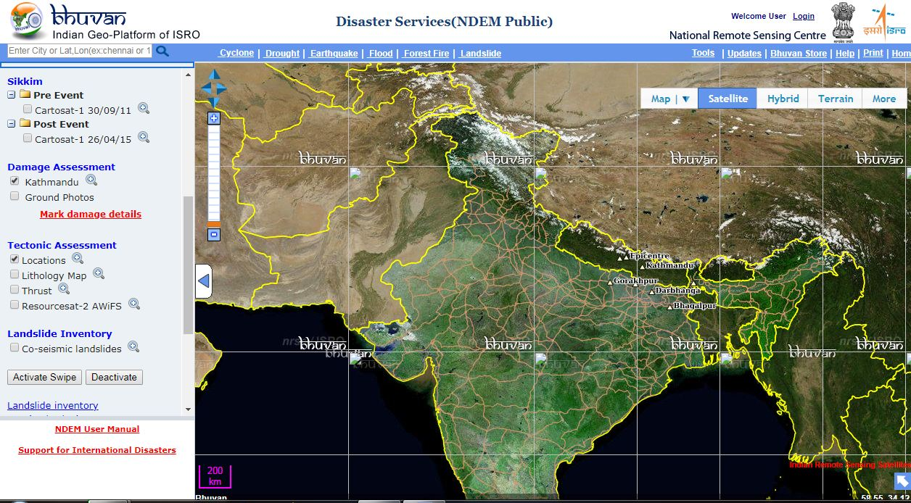

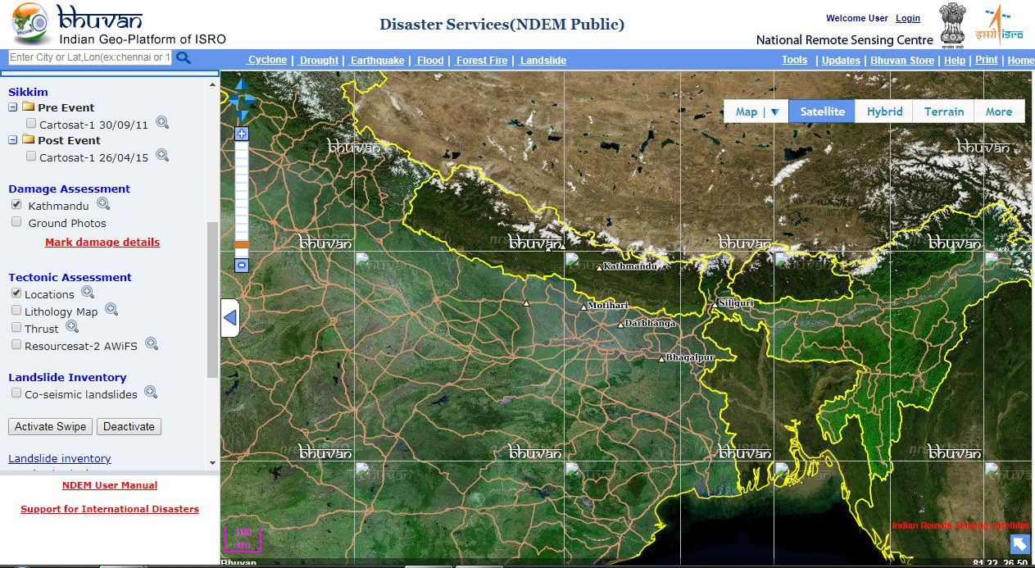

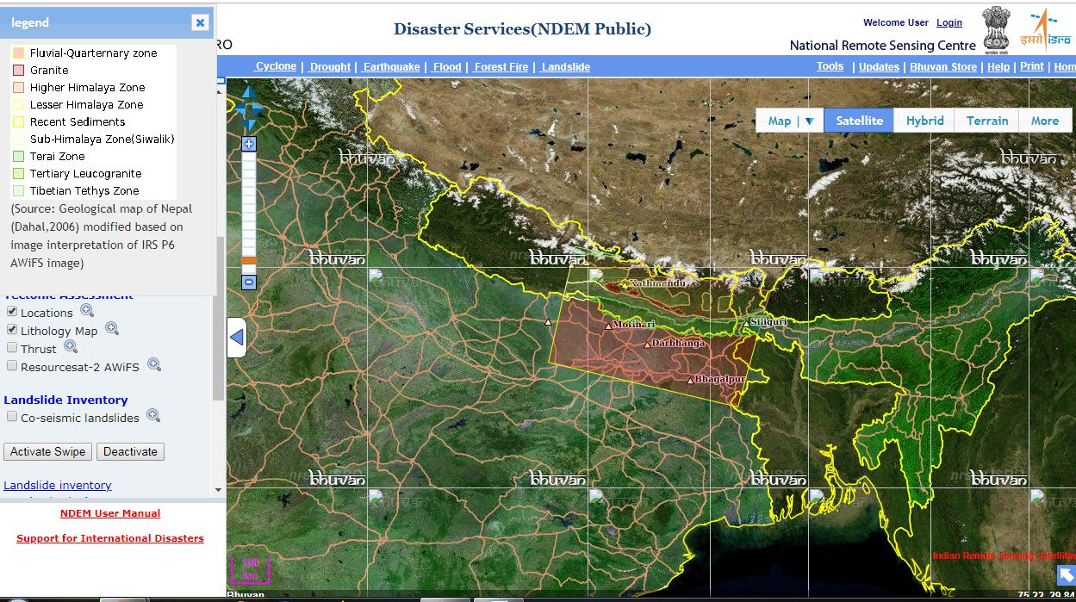

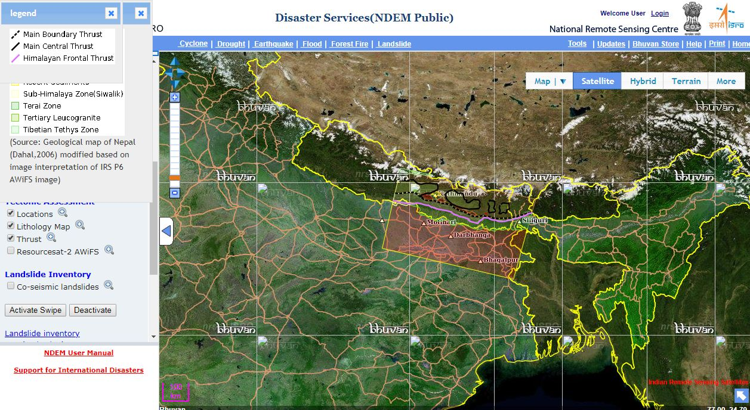

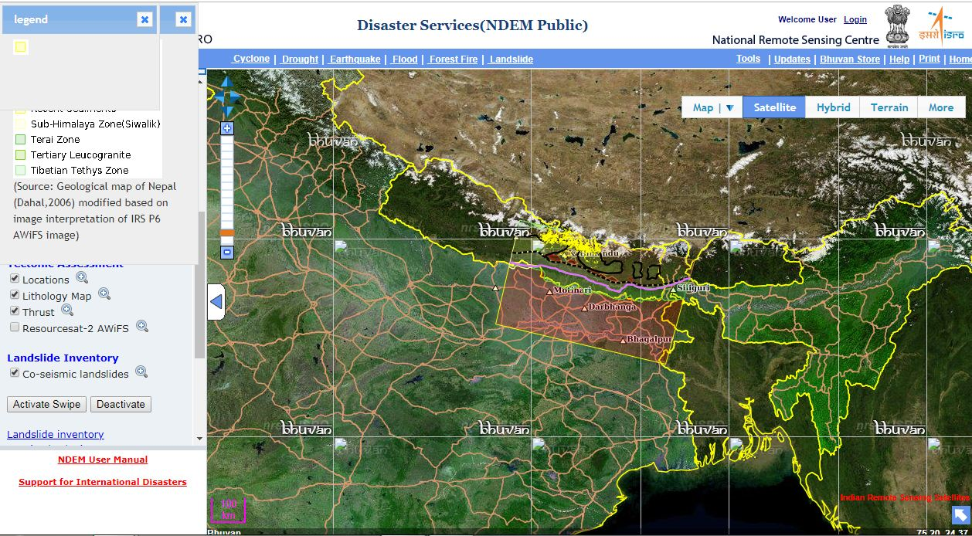





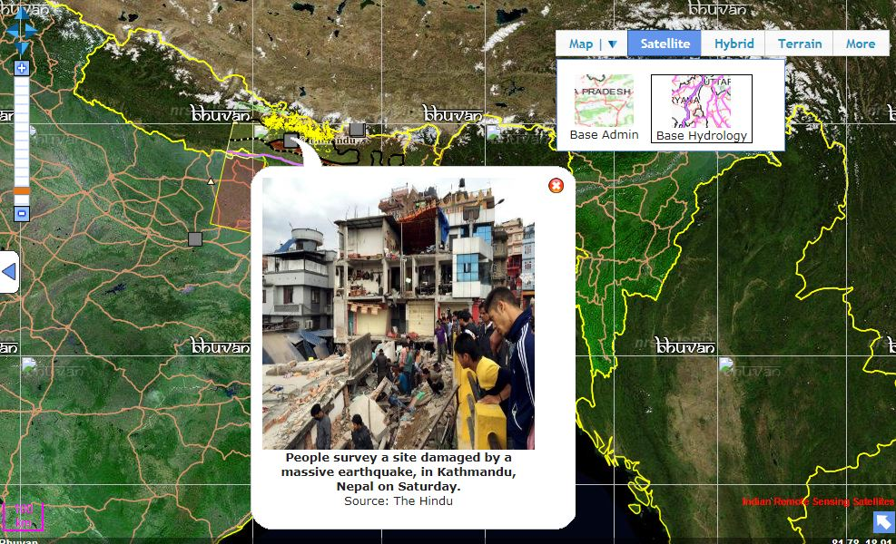



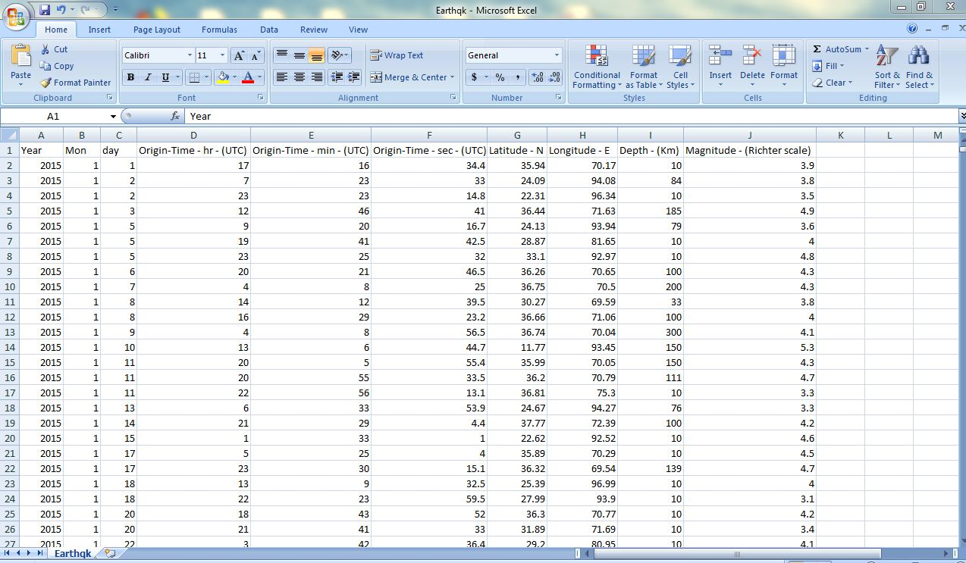

(source: data.gov.in)

Earthqk1 <- read.csv("C:/Users/ACER/Desktop/pro/ES/Earthqk.csv")

|  |
| --- |
| colnames(Earthqk1)[7] <- "lat"  colnames(Earthqk1)[8] <- "long"  colnames(Earthqk1)[9] <- "Depth"  colnames(Earthqk1)[10] <- "Mag"  View(Earthqk1)  #the largest earthquakes occur at shallower depths in the earth's crust, but smaller earthquakes can and do occur at all depths down to about 700 km (400 mi).  Earthquakes occur in the earth's crust, the topmost layer of the earth, which is typically 7 to 30 km (4 to 18 mi) thick. The crust is the coldest and most brittle part of the earth, and has many fault systems on which earthquakes occur. These earthquakes are caused by the buildup of tectonic stress, and result in frictional sliding on the faults.  C:\Users\ACER\Desktop\eqdataset2.JPG |
|  |
| |  | | --- | | **attach(Earthqk1)**  **plot(Mag, Depth,**  **ylab = "Depth wise Reporting",**  **xlab = "Magnitude",**  **main = "Earthquakes Magnitude and Depth wise Reporting")**  **C:\Users\ACER\Desktop\dep1.JPG**  **plot(jitter(Mag, amount = 0.05), Depth,**  **pch = 20,**  **ylab = "Depth wise Reporting",**  **xlab = "Magnitude",**  **main = "Earthquakes Magnitude and Depth wise Reporting",**  **col = rgb(0.1, 0.2, 0.8, 0.3))**  **C:\Users\ACER\Desktop\dep2.JPG**  **Linear model:**  **EQ.lm<- lm(Depth ~ Mag)**  **EQ.lm**  **C:\Users\ACER\Desktop\dep3.JPG**  **# Linear model:**  **Depth = ( -45.24 ) + (25.10)(Magnitude)**  **Abline:**  **plot(jitter(Mag, amount = 0.05), Depth,**  **pch = 20,**  **ylab = "Depth wise Reporting",**  **xlab = "Magnitude",**  **main = "Earthquakes Magnitude and Depth wise Reporting",**  **col = rgb(0.1, 0.2, 0.8, 0.3))**  **abline(-45.24, 25.10, col="red", lwd = 2)**  **C:\Users\ACER\Desktop\dep4.JPG**  **# Assumption 1: Homoscedasticity**  **Homoscedasticity means that the variance of our residuals is constant across all earthquake magnitudes. Put another way, the variance of our residuals is independent of our predictor variable. There are a few ways that we can check the variance of our residuals starting with the original scatter plot without jitter and adding guide lines using the abline command in hot pink for variation reference.**  **plot(Mag, Depth,**  **pch = 20,**  **ylab = "Depth wise Reporting",**  **xlab = "Magnitude",**  **main = "Earthquakes Magnitude and Depth wise Reporting",**  **col = rgb(0.1, 0.2, 0.8, 0.3))**  **abline(-160, 35, col="hotpink", lwd = 2)**  **abline(-5, 35, col="hotpink", lwd = 2)**  **C:\Users\ACER\Desktop\dep5.JPG**  **#As we compare the spread of the data, the variation appears to be relatively constant across the plot except for the lowest earthquake magnitudes**  **#Our primary option for checking the variance in residuals is a residual plot with our model’s fitted values on the X-axis and residual size on the Y-axis. This residual plot allows us more clearly to see changes in the variance of the residuals across all magnitudes compared to the scatter plot. Since R is pretty neat, we can directly compute our residuals and fitted values with some simple code. We will create another function for our residuals (QuakeResiduals) and fitted values (QuakeFittedValues) and then construct our residual plot with a horizontal line at Y equals zero as a reference point for the variation in our residuals.**  **Residual Plot**  **EQResiduals<- EQ.lm$residuals**  **EQFittedValues<- EQ.lm$fitted.values**  **plot(EQFittedValues, EQResiduals,**  **pch = 20,**  **xlab= "Magnitude",**  **ylab= "Residual",**  **main= "Residual Plot",**  **col = rgb(0.1, 0.2, 0.8, 0.3))**  **abline(0,0,col="brown", lwd = 2.5)**  **C:\Users\ACER\Desktop\dep6.JPG**  **#Assumption 3: Errors are normally distributed** Residual Histogram **hist(EQResiduals, breaks=25,**  **xlab="Residual Value",**  **ylab="Frequency",**  **main="Histogram of Residuals",**  **col="cyan")**  **C:\Users\ACER\Desktop\dep7.JPG** Q-Q Plot **qqnorm(EQResiduals, col="blueviolet")**  **qqline(EQResiduals, col="darkgreen")**  **C:\Users\ACER\Desktop\dep8.JPG** Model Accuracy and PrecisionConfidence Intervals for Regression Coefficients: **Depth = ( -45.24 ) + (25.10)(Magnitude)**  **confint(EQ.lm, level=.95)**  2.5 % 97.5 %  (Intercept) -67.47480 -23.00167  Mag 19.75451 30.44474  **plot(jitter(Mag, amount = 0.05), Depth,**  **pch = 20,**  **ylab = "Depth wise Reporting",**  **xlab = "Magnitude",**  **main = "Earthquakes Magnitude and Depth wise Reporting",**  **col = rgb(0.1, 0.2, 0.8, 0.3))**  **abline(**-67.47480**, 25.10, col = 'black', lwd = 2)**  **abline(-45.24, 25.10, col="red", lwd = 2)**  **abline(**-23.00167**, 25.10, col = 'black', lwd = 2)**  **C:\Users\ACER\Desktop\dep9.JPG** Confidence and Prediction Intervals for Response Variable : EQ.m<- data.frame(mag=4.5)  Response Confidence Interval:  Depth.confidenceint<- predict(EQ.lm, EQ.m, interval="confidence", level = .95)  Depth.confidenceint  fit lwrupr  1 52.65031 49.03807 56.26255  Response Prediction Interval:  Depth.predictionint<- predict(EQ.lm, EQ.m, interval="prediction", level = .95)  Depth.predictionint  fit lwrupr  1 52.65031 -92.147837 197.4485 Correlation: Summary(Model)  summary(EQ.lm)  Call:  lm(formula = Depth ~ Mag)  Residuals:  Min 1Q Median 3Q Max  -130.50 -45.16 -28.83 27.33 529.84  Coefficients:  Estimate Std. Error t value Pr(>|t|)  (Intercept) -45.238 11.338 -3.99 6.87e-05 ***  Mag 25.100 2.725 9.21 < 2e-16 ***  ---  Signif. codes: 0 ‘***’ 0.001 ‘**’ 0.01 ‘*’ 0.05 ‘.’ 0.1 ‘ ’ 1  Residual standard error: 73.8 on 1776 degrees of freedom  Multiple R-squared: 0.04558, Adjusted R-squared: 0.04505  F-statistic: 84.82 on 1 and 1776 DF, p-value: < 2.2e-16  Further, we can take the square root of R-Squared and get the correlation coefficient, r. r measures the strength of the linear relationship between the response and predictor variables. r can range from -1 to 1 with -1 being a very strong negative relationship while +1 being a strong positive relationship. If r is 0, that indicates that there is a very weak or no relationship between the two variables. The cor function will produce our r value by inputting our predictor and response variables.  cor  cor(Mag, Depth)  [1] 0.2135021  With a correlation of 0.2135021, we can say that there is a fairly strong linear relationship between magnitude of earthquake and the Depth. As a quick check, our r value should always reflect our slope coefficient such that if the slope is positive, r should be positive as well. Testing Significance An important part of doing any task is evaluating if what you are doing is actually important. We are able to perform this self-analysis in our SLR Model as well through hypothesis tests on the t and F distribution. For both tests, we will use an **alpha of 0.05.** Hypothesis Testing for Regression Coefficients Hypothesis tests for the SLR model follow a very similar format to that of hypothesis tests discussed in mathematical statistics courses, so we will tailor our approach and analysis beyond the introductory level.  Our goal of hypothesis testing is to test if there is linear relationship between our response and predictor variable. We test this through examining the slope of the regression model.  With our null hypothesis being the slope equals zero, we will fail to reject the null when we believe there is no linear relationship between quake magnitude and the number of stations reporting. On the contrary, when we believe the slope does not equal zero we will reject the null and conclude there is a linear relationship. (Hypothetically, we could perform a one-sided test, but the standard two-sided test will serve our purpose of testing significance the best.)  We can use the summary function we introduced in the last section to analyze the hypothesis test results.  t-test  This time, we’ll focus our attention on the Coefficients section of the R output. For both the slope and intercept coefficients, we’re provided the test statistic and the p-value in the last two columns of the hypothesis test. Both the slope and intercept have large test statistics (-3.99 and 9.21 respectively) and consequently small p-values (both essentially 0), which means that we will reject the null hypothesis for both the slope and the intercept and conclude that both parameters are significant to our SLR Model. Therefore, the model is worth conducting. If instead one or both of our coefficients produced a p-value larger than our alpha significance level, we would fail to reject the null and remove the insignificant parameter(s) from the model.  Create contingency tables  t1<-table(Earthqk1$lat,Earthqk1$long)  t2<-table(Earthqk1$Depth,Earthqk1$Mag)  **library**(psych)  boxplot(lat~long,data=Earthqk1,notch=FALSE)  C:\Users\ACER\Desktop\lat1.JPG  boxplot(Mag~Depth, data=Earthqk1,notch=FALSE)  C:\Users\ACER\Desktop\lat2.JPG  library(corrgram)  corrgram(Earthqk1, lower.panel=panel.shade,  upper.panel=panel.pie, text.panel=panel.txt,  main="Corrgram of Earthquake Variables")  C:\Users\ACER\Desktop\lat3.JPG  ScatterPlots  plot(Earthqk1$lat,Earthqk1$long, main="latitude vs longitude", xlab="lat", ylab="long", pch=10)  C:\Users\ACER\Desktop\lat4.JPG  plot(Earthqk1$Depth,Earthqk1$long, main="depth vs longitude", xlab="depth", ylab="long", pch=10)  C:\Users\ACER\Desktop\lat5.JPG  plot(Earthqk1$Depth,df1$lat, main="depth vs latitude", xlab="depth", ylab="lat", pch=10)  C:\Users\ACER\Desktop\lat6.JPG  **t.test(Earthqk1$lat,Earthqk1$long, data=Earthqk1)**  Welch Two Sample t-test  data: Earthqk1$lat and Earthqk1$long  t = -191.54, df = 3319, p-value < 2.2e-16  alternative hypothesis: true difference in means is not equal to 0  95 percent confidence interval:  -55.19860 -54.07996  sample estimates:  mean of x mean of y  28.35973 82.99901  t.test(Earthqk1$Depth,Earthqk1$long, data=Earthqk1)  data: Earthqk1$Depth and Earthqk1$long  t = -13.886, df = 1834.1, p-value < 2.2e-16  alternative hypothesis: true difference in means is not equal to 0  95 percent confidence interval:  -28.61139 -21.52948  sample estimates:  mean of x mean of y  57.92857 82.99901  t.test(Earthqk1$Depth,Earthqk1$lat, data=Earthqk1)  Welch Two Sample t-test  data: Earthqk1$Depth and Earthqk1$lat  t = 16.432, df = 1810.1, p-value < 2.2e-16  alternative hypothesis: true difference in means is not equal to 0  95 percent confidence interval:  26.03964 33.09805  sample estimates:  mean of x mean of y  57.92857 28.35973    **boxplot(Earthqk1$Mag)**  **C:\Users\ACER\Desktop\box1.JPG**  **ggplot(data = Earthqk1) + geom_histogram(aes(x = Mag), bin = .1, fill = 'grey30')**  **C:\Users\ACER\Desktop\box2.JPG**  **boxplot(Earthqk1$Depth)** | |

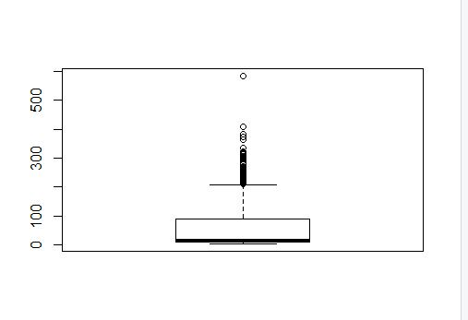

ggplot(Earthqk1) + geom_histogram(aes(x = Depth), bin = 7, fill = 'grey30')

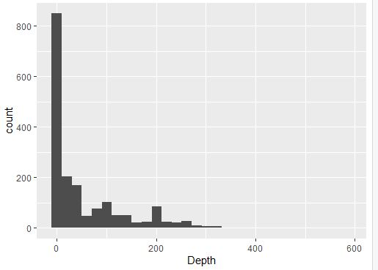

ggplot(Earthqk1) + geom_point(aes(x = long, y = lat, color = Mag)) + facet_wrap(~Mag)

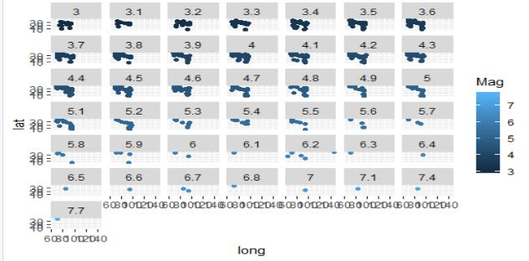

Earthqk1$depthbin4 <- cut_number(Earthqk1$Depth, 4)

ggplot(Earthqk1) + geom_point(aes(x = long, y = lat, color = depthbin4)) + facet_wrap(~depthbin4)

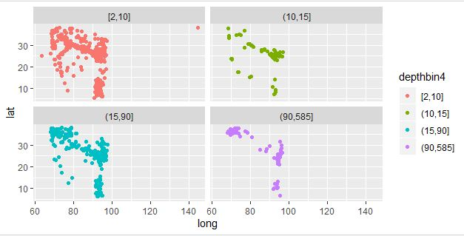

Chennai City :

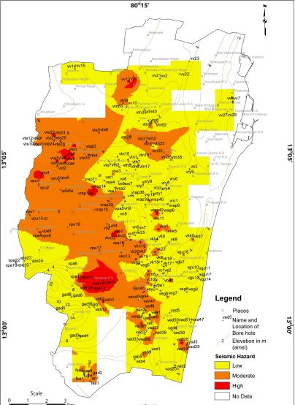

Source :www.nat-hazards-earth-syst-sci.net/11/549/2011/ doi:10.5194/nhess-11-549-2011

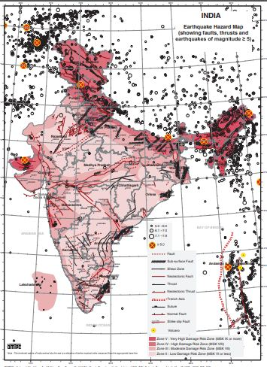

Sourcen: [http://www.bmtpc.org](http://www.bmtpc.org/)

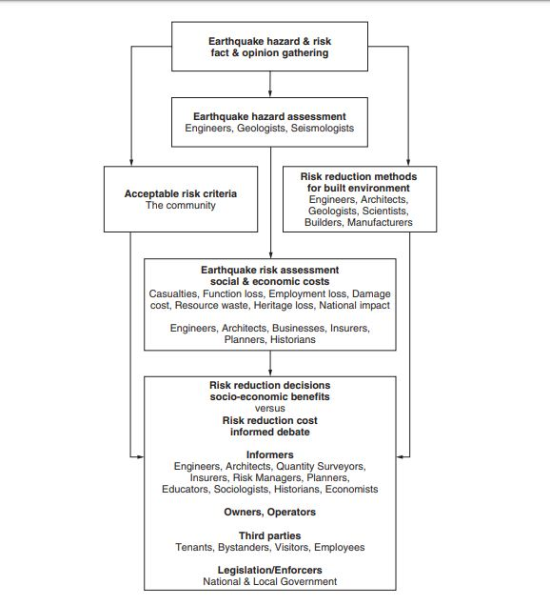

Information flow and those involved in the earthquake risk reduction process

Source :EARTHQUAKE RESISTANT DESIGN AND RISK REDUCTION by David Dowrick

The physical consequence of earthquakes for human beings are generally viewed under two headings: (A) death and injury to human beings; (B) damage to the built and natural environments.

These physical effects in turn are considered as to their social and economic consequences:

(1) numbers of casualties; (2) trauma and bereavement; (3) loss of employment; (4) loss of employees/skills; (5) loss of heritage; (6) material damage cost; (7) business interruption; (8) consumption of materials and energy (sustaining resources); (9) macro-economic impacts (negative and positive).

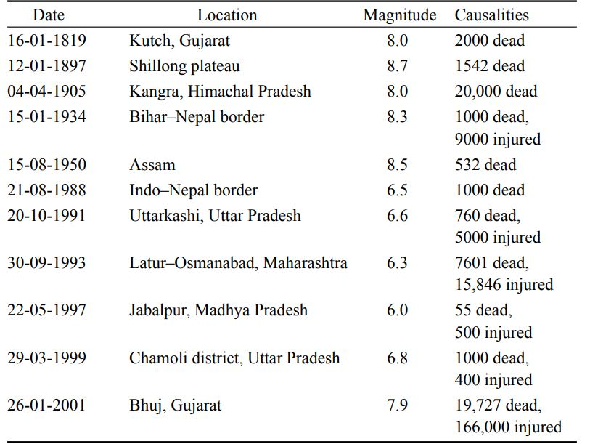

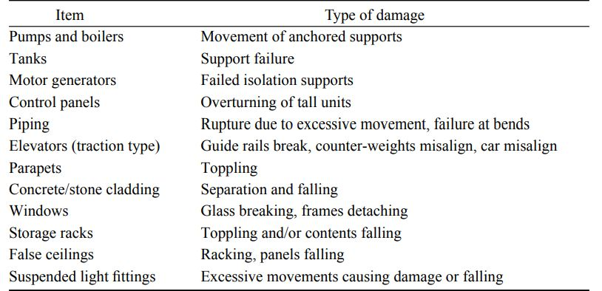



(Seismic zone dataset)

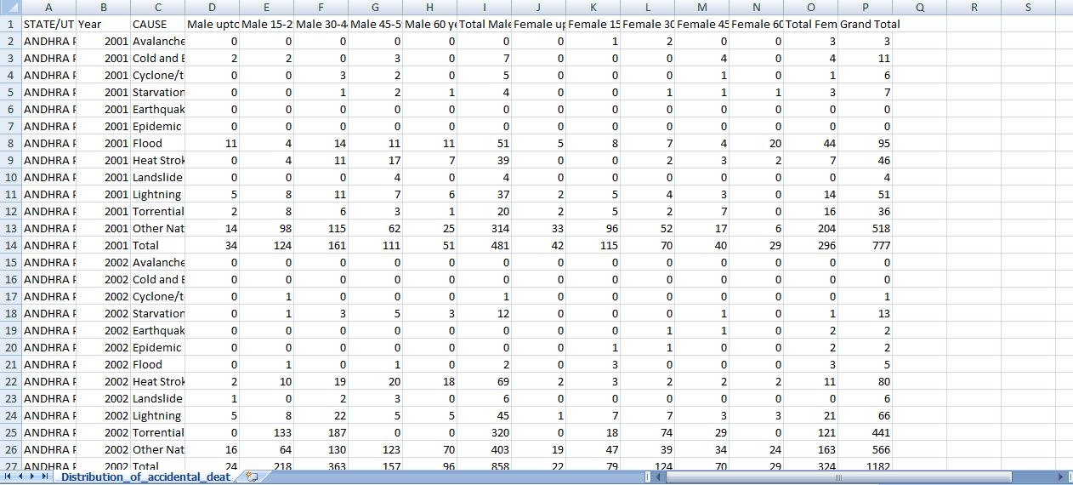

(acci-dataset)

Earthquake life loss- 41106(2001),15(2002),18(2003),132(2004),2172(2005),24(2006),42(2007),18(2008),6(2009),24(2010),207(2011),9(2012)=43773

**Animated cause code:**

p <- ggplot(

cause,

aes(x = Year, y=GrandTotal, size = TotalFemale, colour = STATE)

) +

geom_point(show.legend = FALSE, alpha = 0.7) +

scale_color_viridis_d() +

scale_size(range = c(2, 12)) +

scale_x_log10() +

labs(x = "Year", y = "Total")

p

r <- p + transition_time(Year) +

labs(title = "Year: {frame_time}")

r

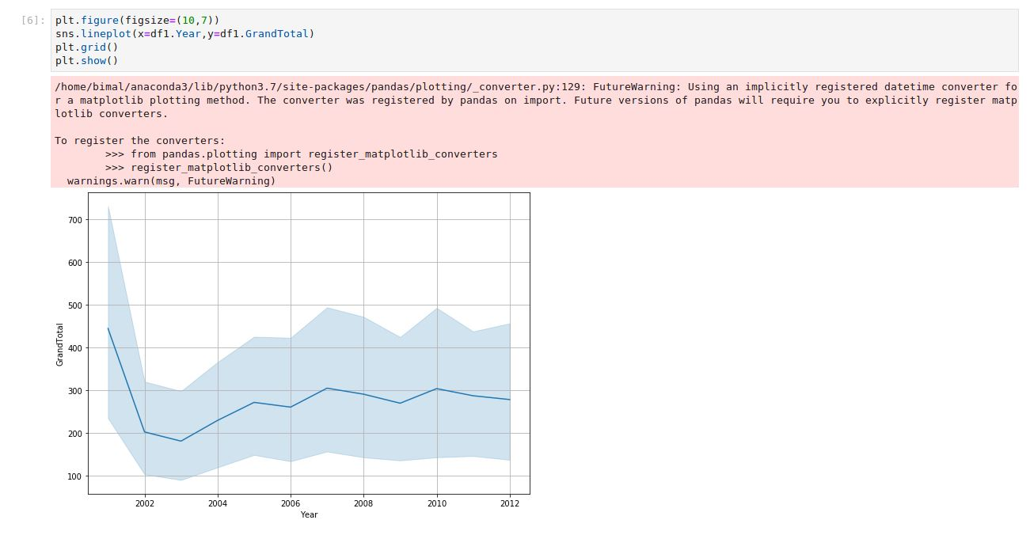

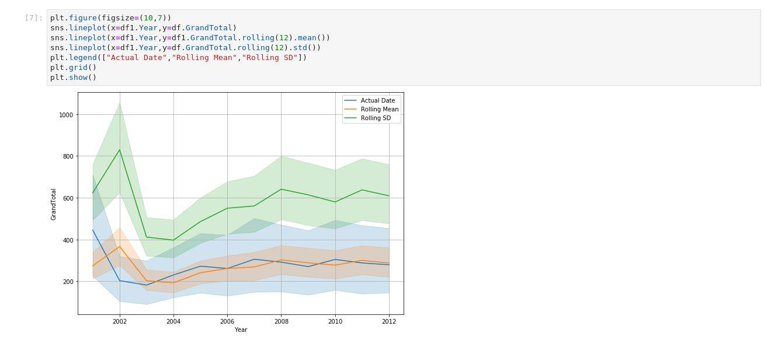

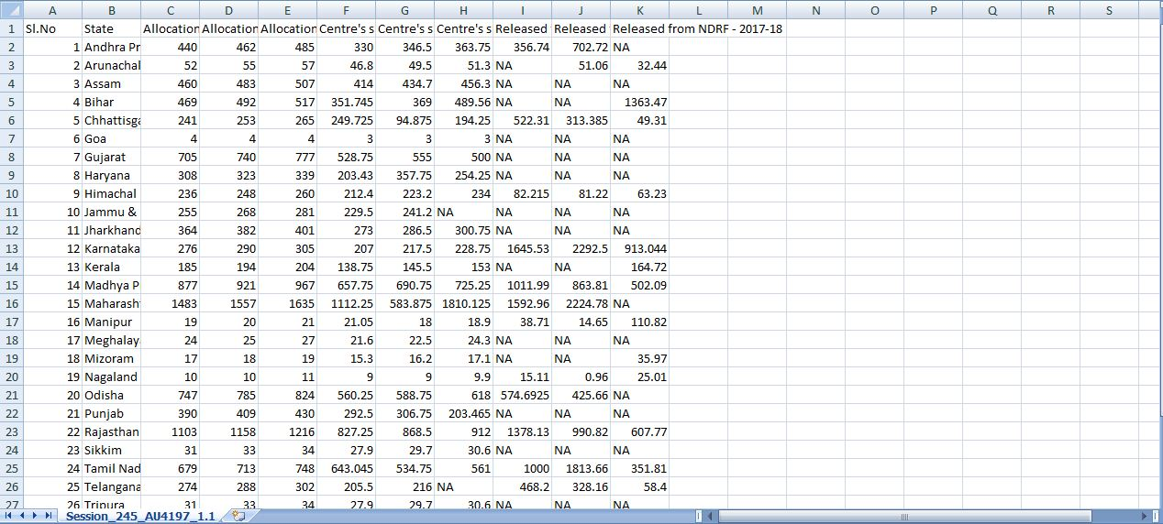

(fund allocation dataset)

All india fund allocation : 90059.54 cr. (2015-2017)

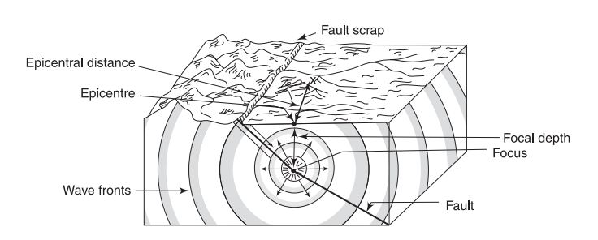

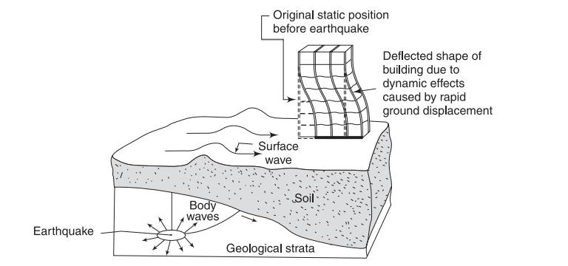

**Effects of Earthquakes:** Direct effects|||

1.destroy buildings, 2. landslides and mudslides,3. Soil vibration-shake a building off its foundation,

4. liquefaction, lurch and damage the structure.

Indirect or consequential effects|||

1. tsunamis(V[tsunamic]=sqrt(gh) , 2. undersea landslides, surface land sliding, volcanic eruptions
2. Sieches, similar to small tsunamis, 4. damaging gas lines and snapping electric wires

5. rupture dams and levees (raised river embankments), causing floods

The annual frequency N of the earthquakes is given by following equation, log N = a – bM

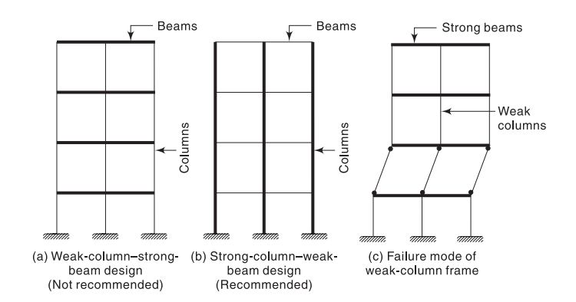

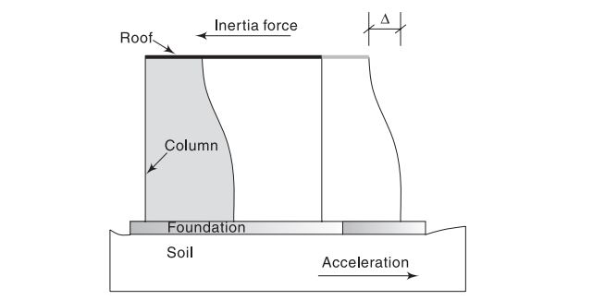

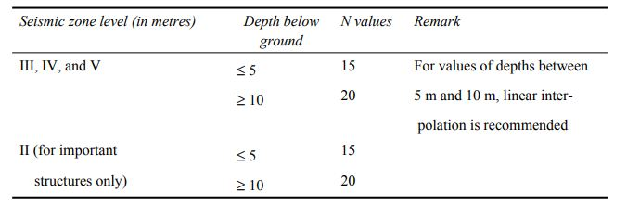

The zone factor (Z), thus, is defined as a factor to obtain the design spectrum depending on the perceived seismic hazard in the zone in which the structure is located. The basic zone factors included in the code are reasonable estimate of effective peak ground acceleration. Zone factors as per IS 1893

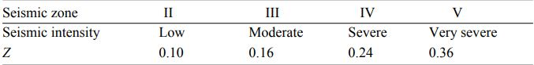

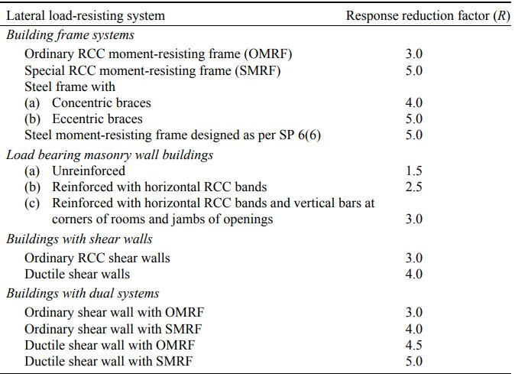

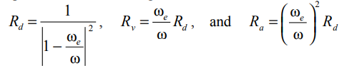

displacement response factor Rd, velocity response factor Rv, acceleration response factor Ra, frequency of the forcing ωfunction, nωnatural frequency of the system w (n),

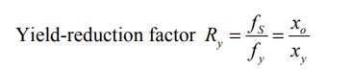fS is the peak resisting force in corresponding linear system and xo is the peak deformation corresponding to fS